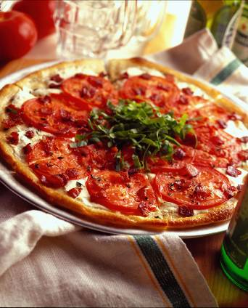

BLT PIZZA
Adapted from Chef Glenn Harris,
Saloon, New York, NY

Ingredient Quantity
Fully ripened fresh Florida tomatoes, 12 ounces (about 1-1/2 large)
thinly sliced
Olive oil 1 tablespoon
Minced fresh thyme 1/2 teaspoon
Ground black pepper 1/4 teaspoon
Bacon, cut in 1/2-inch dice 4 ounces
Prepared pizza dough 6 ounces
Mozzarella, cut in 1/8-inch slice 6 ounces
Thinly sliced arugula 1 cup

- Preheat oven to 450° F. Lightly oil a 10-inch pizza pan. In a bowl, drizzle tomatoes with oil; sprinkle with thyme and pepper. Gently turn slices until well coated
- In a skillet, cook bacon until crisp; drain on paper towels.
- Roll dough to make a 10-inch circle, slightly thicker at edges; arrange on prepared pan. Lay cheese slices on top, leaving a 1/2-inch border at edges; arrange tomatoes in a single layer to cover cheese; scatter bacon on top.
- Bake on lowest rack of oven until crust bottom and edges are browned, about 15 minutes. Arrange a “nest” of arugula in center of pizza.

YIELD: 1 pizza (10 inches)

