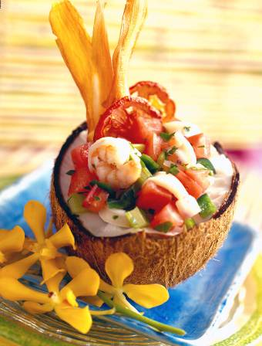
Caribbean-Style Seafood and Fresh Tomato Appetizer
Chef Ramon Medrano, Yuca Restaurant, Miami Beach, FL

Ingredient Quantity
Fully ripened fresh Florida tomatoes, diced 10 ounces
Chopped cilantro 1 cup
Seeded and diced poblano pepper 1/2 cup
Diced celery 1/4 cup
Chopped red onion 2 tablespoons
Seeded and minced jalapeno pepper 2 teaspoons
Salt 1 tablespoon
Sugar 1/4 teaspoon
Medium shrimp, shelled and deveined 1 pound
Squid bodies, sliced in 1/4 inch rings 1 pound
Dried coconut shells, halved 3
Tomato Chips* Recipe follows
Yuca Chips** Recipe follows

- In a bowl, combine tomatoes, cilantro, poblano, celery, red onion, jalapeno, salt and sugar.
- Cook shrimp in boiling water for 40 seconds. Add squid; cook just until seafood is opaque, about 20 seconds longer. Drain and cool; add seafood to tomato mixture.
- To plate: Spoon seafood-tomato mixture into coconut halves or into lettuce cups, dividing evenly. Garnish with Tomato Chips and Yuca Chips

YIELD: 6 servings

*Tomato Chips: Brush a baking sheet with vegetable oil. Using a mandoline, cut 1 medium tomato in paper-thin slices. Arrange in a single layer on a sheet pan. Brush slices lightly with vegetable oil; lightly sprinkle with salt. Bake at 200ºF until crisp, about 3 hours.

**Yuca Chips: Using a mandoline, cut a peeled, 5 ounce piece of yucca in paper-thin slices. In a skillet, over high heat, heat 2 cups vegetable oil. Add half of the yucca slices; fry 2 minutes, turning once; drain on paper towels and cool. Repeat with remaining yucca. Fry chips a second time until brown, about 15 seconds.

