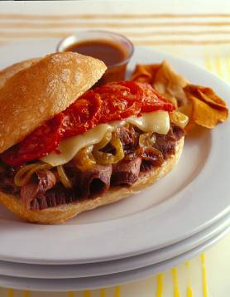
CHURRASCO STEAK SANDWICHES
WITH ROASTED TOMATOES
Executive Chef Brad Grossman,
Café Metro, New York City

Ingredient Quantity
Peruvian Sauce (prepared or housemade) 2/3 cup (recipe follows)
Cooked, thinly sliced steak (such as tri tips or flank steak) 1 – 1/2 pounds
Butter 2 tablespoons
Thinly sliced onions 2 cups
Fully ripened fresh Florida tomatoes, sliced 1 pound
Olive oil 1 tablespoon
Salt 1/2 teaspoon
Ground black pepper 1/8 teaspoon
Portuguese or other sandwich rolls, split 4
Jack or Pepper Jack cheese, sliced 4 ounces

- Set aside 1/4 cup of the Peruvian Sauce; marinate steak in remaining sauce for at least 1 hour.
- In a skillet, over medium-low head, melt butter. Cook onions until very tender and caramelized, about 25 minutes.
- Preheat oven to 450 F. On a baking sheet, arrange tomato slices in a single layer. Brush with oil; sprinkle with salt and pepper. Roast until softened, about 15 minutes.
- To make sandwiches: Brush the reserved 1/4 cup Peruvian Sauce on rolls, dividing evenly. Arrange marinated steak slices on bottom halves of rolls; add layers of caramelized onions, cheese and roasted tomato slices; top with remaining roll halves. Bake until cheese melts and tops of rolls are crisp, about 5 minutes.
YIELD: 4 sandwiches

Peruvian Sauce: In a bowl, combine 1/2 cup honey mustard, 2 tablespoons honey, 1 tablespoon cider vinegar, 2 teaspoons packed dark brown sugar, 3/4 teaspoon chili sauce, 1/2 teaspoon minced garlic, 1/2 teaspoon coarse black pepper, 1/4 teaspoon crushed red pepper and 1/8 teaspoon ground ginger; whisk until blended.
YIELD: about 2/3 cup

