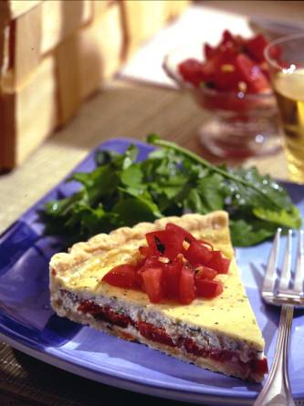
ROASTED FLORIDA TOMATO TART WITH
FRESH TOMATO SALSA
Rhonda Groh, Oakland Community College, Bloomfield Hill, MI
Winning entry in 2002 Florida Tomato Committee Recipe Contest

Ingredient Quantity
Olive oil 2 tablespoons
Minced garlic 1 teaspoon
Salt 1/4 teaspoon
Ground black pepper 1/8 teaspoon
Fully ripened fresh Florida tomatoes 2 pounds (4 large)
All-purpose flour 1 cup
Butter 4 tablespoons
Shortening 1 tablespoon
Toasted, coarsely chopped pine nuts 1 tablespoon
Ricotta cheese 1/2 cup
Boursin cheese 1 (5.2 ounces) package
Egg, separated 1
Minced basil 2 tablespoons, divided
Fresh Tomato Salsa Recipe follows

- Preheat oven to 425° F. In a small bowl, combine olive oil, garlic, salt and pepper; set aside.
- Cut tomatoes in slices 1/2-inch thick. Arrange slices on a parchment-lined baking sheet; brush lightly with the reserved seasoned oil mixture. Roast until excess moisture has evaporated and tomatoes are slightly shriveled, about 20 minutes.
- In a bowl, cut butter and shortening into flour, using two knives or a pastry blender, until mixture resembles large peas. Add pine nuts; using a fork, stir in 1 tablespoon water at a time just until dough forms (3 to 4 tablespoons water). Wrap in plastic wrap; chill up to 1 hour.
- On a lightly floured surface, roll pastry into an 11-inch circle. Fit into a 9-inch tart pan. Trim edge and pierce pastry with fork tines. Bake at 425°F until edges just start to brown, about 10 minutes. Remove pastry from oven; reduce heat to 350°F.
- In a bowl, blend together ricotta, boursin, egg yolk and 1 tablespoon of the basil. Beat egg white until frothy; gently stir into cheese mixture.
- Arrange tomato slices in prepared pastry shell, overlapping as necessary. Pour cheese mixture over tomatoes; smooth top with a knife. Bake at 350°F until filling is set, about 35 minutes (do not brown). Cool and cut in wedges.
- Serve tart topped with Fresh Tomato Salsa; garnish with fresh basil leaves and toasted pine nuts, if desired.

Fresh Tomato Salsa: Seed and coarsely chop 1 fully ripened Florida tomato. Toss with 1 tablespoon minced basil, 1/4 teaspoon salt and 1/8 teaspoon ground black pepper.

YIELD: 8 portions (1-1/4 cups salsa)

