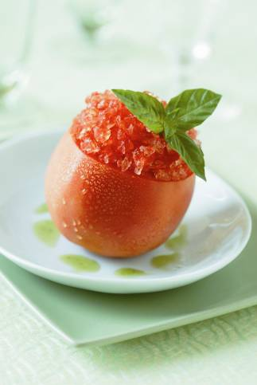
Fresh FLORIDA Tomato GranitA with Basil Syrup
Alisa Malavenda, Milwaukee Area Technical College, Milwaukee, WI
Winning entry in 2003 Florida Tomato Committee Recipe Contest

Ingredients Quantity
Fully ripened medium-sized fresh 3 pounds (about 7) Florida tomatoes
Honey 2 tablespoons
Sugar 2 tablespoons
Ground black pepper 1 teaspoon
Balsamic vinegar 1 teaspoon
Salt 1/4 teaspoon
Fresh basil leaves 1/4 cup packed
Light corn syrup 1/3 cup

- To prepare tomato shells: Halve 3 tomatoes crosswise; scoop out pulp and set aside. Set tomato shells in a baking pan; cover and freeze.
- To prepare Fresh Tomato Granita: Remove seeds from the reserved tomato pulp; place in a bowl. Blanch, peel, seed, and coarsely chop remaining tomatoes; add to prepared tomatoes (makes about 3 cups).
- Place tomatoes in a food processor container fitted with a wing blade. Add honey, sugar, pepper, vinegar, and salt; process mixture until smooth. Transfer to a freezer container; cover and freeze until firm, 6 to 8 hours; stir occasionally with a fork to break up ice crystals.
- To make Basil Syrup: Blanch and drain basil leaves. In a blender or small food processor container, combine with corn syrup; process until smooth. Set mixture aside to infuse for about 30 minutes; strain and refrigerate until ready to serve.
- To serve: Scoop granita into frozen tomato shells. Place each filled tomato on a chilled dessert plate. Top with a drizzle of basil syrup. If desired, sprinkle with black pepper and garnish with a basil sprig.

YIELD: 6 portions

