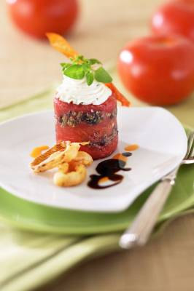

FLORIDA TOMATO AND TAPENADE GATEAUX
WITH CHIVE GOAT CHEESE
Stuart Tracy, Johnson & Wales University, Charleston, SC
Winning entry in 2005 Florida Tomato Committee Recipe Contest

Ingredient Quantity
Fully ripened fresh Florida tomatoes 3 large (about 10 ounces each)
Pitted niçoise or kalamata olives 1/3 cup
Pitted green olives 1/3 cup
Fresh basil leaves 4
Anchovy fillet 1
Capers 1 teaspoon
Chopped garlic 1/4 teaspoon
Fresh marjoram or oregano 1/4 teaspoon
Extra virgin olive oil 4 tablespoons, divided
Fresh lemon juice 1 tablespoon
Dijon mustard 1/2 teaspoon
Goat cheese 3 ounces
Milk 1 1/2 tablespoons plus 1/4 cup
Chopped chives 1 teaspoon
Salt As directed
Ground black pepper As directed
Shallots, sliced into 1/4-inch thick rings 3 very large
All-purpose flour 2 tablespoons
Vegetable oil for frying

- Over high heat bring a medium saucepan of water to a boil. Score the skin of each tomato into 6 sections. Blanch tomatoes, one at a time in the boiling water; core tomatoes and carefully peel off skin. Pat skin dry on paper towels; reserve.
- Cut each tomato into 6 wedges; remove and reserve centers (pulp) of each wedge (petal). Reserve the 16 best looking petals. Remove seeds from the tomato centers; chop along with the remaining two petals and reserve.
- To make the tapenade, in the bowl of a food processor, combine olives, the basil, anchovy, capers, garlic, if using, marjoram, and 1/2 cup of the reserved chopped tomato. Process until finely chopped. With the motor running, through the food tube, add 1 tablespoon of the olive oil.
- Set four 2- by 2-inch metal rings on a plate. In each, layer 2 tomato petals, 1 tablespoon tapenade, 1/4 cup chopped tomato, 1 tablespoon tapenade, and 2 tomato petals. Cover, add a weight, and refrigerate until ready to serve.
- For the dressing whisk together the remaining 3 tablespoons olive oil, the lemon juice and mustard; set aside.
- About 10 minutes before serving, beat together goat cheese, 1-1/2 tablespoons milk, chives, 1/8 teaspoon salt, and 1/8 teaspoon ground black pepper; place in a small plastic bag or disposable pastry bag.
- In a bowl combine shallots and 1/4 cup milk. In a plastic bag combine flour, 1/4 teaspoon salt, and 1/4 teaspoon pepper. In a small saucepan over medium-high heat, heat 2 inches of vegetable oil. When oil is hot, add the tomato skins a few at a time and fry until crisp. Remove to paper towels to drain. Remove the shallot rings, several at a time from the milk and toss with the flour mixture in the bag. Fry until crisp and golden; remove to the paper towels and repeat until all shallot rings have been fried.
- To serve, transfer tomato gateaux to 4 chilled salad plates; remove rings. Pipe a swirl of goat cheese onto the top of each and drizzle with the dressing. Garnish with the fried tomato skins and shallot rings. Garnish plate with parsley and red pepper infused oils, and balsamic reduction, if desired.

YIELD: 4 servings

