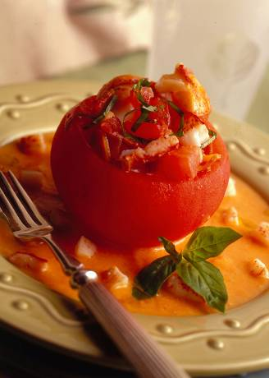

TOMATOES WITH LOBSTER AND PANCETTA STUFFING
Chef David Ulrich, Caliterra, Boston, MA

Ingredient Quantity
Fully-ripened fresh Florida tomatoes, 4 large
blanched and peeled
Extra-virgin olive oil 1 tablespoon
Cooked lobster meat 3/4 cup, divided
Diced, cooked pancetta 1/4 cup
Diced red onion* 1/4 cup
Basil chiffonade 1/4 cup
Ground black pepper Pinch
Tomato Coulis** Recipe follows

- Preheat over to 300° F. Cut top third off tomatoes. Scoop out pulp from tomatoes; discard seeds and dice pulp. Place pulp in a medium bowl; mix in olive oil, 1/2 cup of the lobster, the pancetta, onion, basil and pepper. Fill each tomato shell with about 1/2 cup of the mixture.
- Arrange stuffed tomatoes in a baking dish; bake until hot, about 25 minutes.
- Spoon about 3 tablespoons Tomato Coulis on each of 4 serving plates; place a tomato in center. Scatter remaining 1/4 cup diced lobster around tomatoes. Garnish with basil leaves, if desired.

Yield: 4 portions

*Tip: To lessen sharpness, soak onion in 1 cup ice water for 10 minutes. Drain and pat dry.

**Tomato Coulis: Coarsely chop 1 pound blanched, peeled and seeded Florida tomatoes. In a large skillet, over medium-high heat, heat 3 tablespoons extra virgin olive oil. Add tomatoes and 1/4 cup chopped shallots, 1/2 teaspoon salt and 1/4 teaspoon pepper. Cooked until thickened. In a blender, puree the tomato mixture, drizzling 1 more tablespoon extra-virgin olive oil through feed tube. Yield: about 1-1/4 cups.

